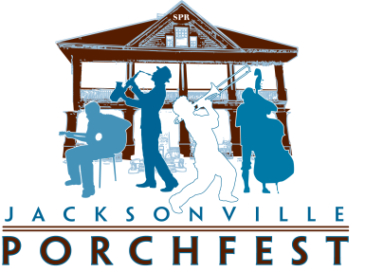

2016 Jacksonville PorchFest
Poster Contest Application

Contact Information:

Name:

Address:

City: State:

Telephone:

Email Address:

Website / Facebook / Instagram:

I understand that, if selected, my artwork shall become the property of Springfield Preservation and Revitalization Council, Inc. (“SPAR”), and by submitting the artwork for this competition, release all rights for use of the original artwork and digital and printed reproductions of all or part of the artwork to SPAR.

I understand that SPAR will add text and logos to the image of my artwork for promotional materials, poster, and merchandise for this year’s event.

Participation in this contest represents my full and unconditional agreement with and acceptance of the Official Rules and Guidelines of the Poster Contest. By participating in the contest, I represent and warrant that I have read and understood and agree to be bound by these rules.

Applicant Signature: Date:

Print Name:

